Software Requirement Specification(SRS)

For

Hotel Management System(HMS)

**1.Introduction**

**1.1 Purpose:**

This document is meant to delineate the features of HMS, so as to serve as a guide to the developers on one hand and a software Validation document for the prospective client on the other.

This project aims to creating on Hotel Management System which can be used by Admin and Customers. The admin to publish the availability of rooms in different hotels and customers are checking the availability of room in required hotel. Customers should be able to know the availability of the rooms on a particular date to reserve in hotel according to their location. They should be able to reserve the available rooms according to their need in advance to make their stay comfortable. The Admin hands the booking information of customers. The users can register and login into system. The hotel department maintain the seat availability and booking details in certain database. The administrator will know the details of reservation and daily income.

**1.2 Scope:**

This system allows the manager to post available rooms in the system. Customer can view and book hotel rooms online in advance according to their suitable location and cancel their room booking. Admin has the power of either approving or disapproving the customer’s booking request.

**1.3 Definitions:**

HMS – Hotel Management System (for book hotel rooms)

SRS- Software Requirement Specification

GUI- Graphical User Interface

Stackholder - The person who will participate in system

Ex. Customer, Administrator, Employees, etc.

**1.4 Overview:**

This system provides an easy solution for customers to book hotel rooms online in advance according to their location and dates without going to the hotel.

This proposed system can be used by any native users and it does not require any educational level, experience or technical expertise in computer field but it will be of good use if user has the good knowledge of how to operate a computer.

**2.Overall Description**

The Hotel Management System (HMS) is a web-based application that allows the hotel manager to handle all hotel activities online. Interactive GUI and the ability to manage various hotel bookings and rooms make this system very flexible and convenient. This application gives him the power and flexibility to manage the entire system from a single online system. Customer can view and book room online. Hotel Management project provides room booking, staff management, food & beverages.

**2.1 Product perspective:**

The main perspective of this project is to provide a online platform for Booking of hotel’s room with secure payment option and easy done.

This is basically similar to going hotel and booking that we have. But with the use of computers for creating online platform, it will be easy for people to book hotel at any time.

**2.2 Product Functions:**

Hotel Management System should support this use case:

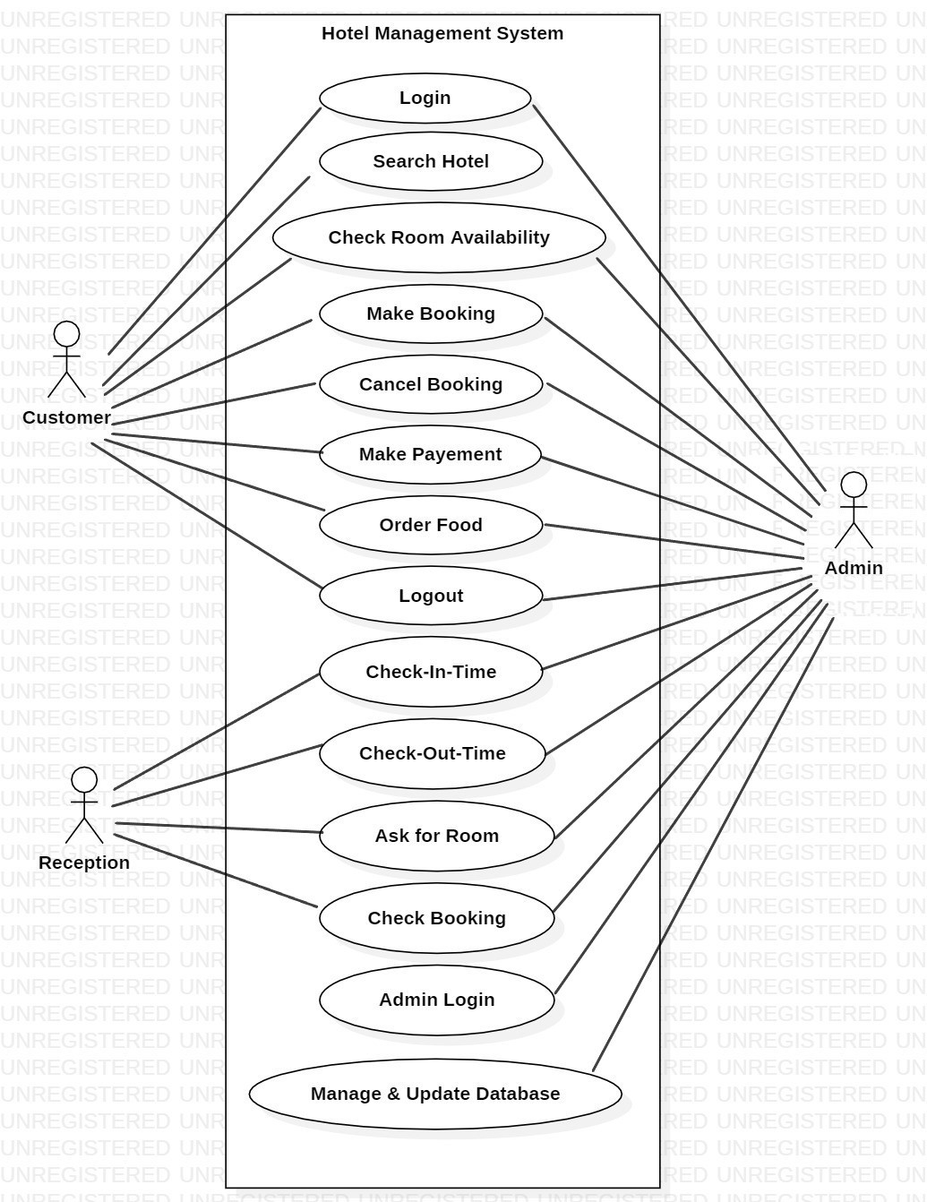

**2.3 User Characteristics:**

User should be familiar with the terms like login, Register, Book Rooms etc.

**2.4 Principle Actors:**

Principle Actors are Customer and Administrator.

**2.5 General Constraints:**

A full internet connection is required for HMS.

**2.6 Assumptions and Dependencies:**

Working of HMS need Internet Connection.

**3.Specific Requirements:**

**3.1 Functional Requirements:**

This section provides requirement overview of the system.

Various Functional modules that can be implemented by the system will be-

**3.1.1 Registration**

If customer wants to book the rooms then they must be registered, unregistered user can’t book the rooms.

**3.1.2 Login**

Customer logins to the system by entering valid user id and password for the booking.

**3.1.3 Payment**

In this system we are dealing the mode of payment by Cash.

**3.1.4 Logout**

After booking or canceling for the Hotel room, customer has to logout.

**3.1.5 Report Generation**

After booking the room, the system will generate bill and update the data into the database.

**3.2 Non- Functional Requirements:**

Following Non-Functional Requirements will be there in the insurance to the internet:

1. Secure access to consumer’s confidential data.
2. 24 X 7 availability.
3. Better component design to get better performance a peak time.
4. Flexible service based architecture will be highly desirable for future extension. Non-Functional Requirements define system

Properties and constraints.

Various other Non-Functional Requirements are:

* **Security**
* **Reliability**
* **Maintainability**
* **Portability**
* **Extensibility**
* **Reusability**
* **Compatibility**
* **Resource Utilization**

**3.3 Performance Requirements:**

In order to maintain an acceptable speed at maximum number of uploads allowed from a particular customer as any number of users can access to the system at any time.

Also the connections to the servers will be based on the attributes of the user like his location and server will be working 24 X 7 times.

**3.4 Technical Issues:**

This system will work on client-server architecture. It will require an internet server and which will be able to run java application. The system should support some commonly used browser such as IE, Chrome, Firefox, etc.

**4.Interface Requirements:**

1)The customers are able to register their details during their online visit.

2)The system will record the details of customers.

3)Then After login customers are directed to their Home page.

4)The system enables the customers to check hotels according to their

Location.

5)The system enables the customers to check availability of rooms.

6)The system should display the type and rate for all rooms.

7)The system enables customers to either confirm or cancel their booking.

8)The system allows manager to update, Add, Delete, booking information.

9)The system is able to generate Financial and Customer report to Admin.

10)The system is able to provide full access to Admin for any changes in

booking, room information and customer information.

**Software Interface:**

1.Operating System : Windows10

2. Java development toolkit.

**Hardware Interface:**

Hardware Requirements for insurance on internet will be same for both parties which are as follows:

Processor : Dual Core

RAM: 8GB

Hard Disk: 1TB

NIC : For each party

**Communication Interface:**

The two parties should be connected by LAN or WAN for the communication purpose.

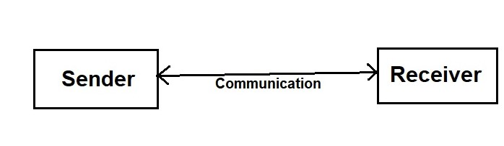

**5.System Design Specification:**

**5.1 Architecture Design:**

**5.1.1 Data Flow Diagram(DFD):**

It is a way of representing system requirements in graphical form, this led to modular design. A DED describes a data flow (Logical) rather than how they are processed. So they do not depend upon software, hardware, data structure or file organization. It is also known as ‘bubble sort’.

A DFD is a structured analysis and a design tool that can be used for flowcharting in place of, or in association with, information-oriented and process-oriented system flowcharts.

A DFD is considered as an abstract of the logic of information-oriented or process-oriented system flowchart. The four basic symbols used to construct data flow diagrams are-

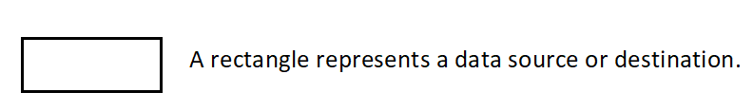



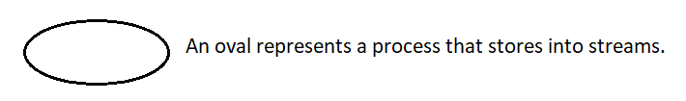

The points at which data is transformed are called as nodes. The principle process that take place at nodes are:

1. Combining data streams
2. Splitting data streams
3. Modifying data streams

